SR UNIVERSITY
AI ASSISTED CODING
LAB TEST – 03
E.RAVALI
2503A51L18
BATCH-19
Set E5
Q1:
Scenario: In the domain of Agriculture, a company is facing a challenge related to web
frontend development.
Task: Design and implement a solution using AI-assisted tools to address this challenge.
Include code, explanation of AI integration, and test results.
Deliverables: Source code, explanation, and output screenshots
CODE:
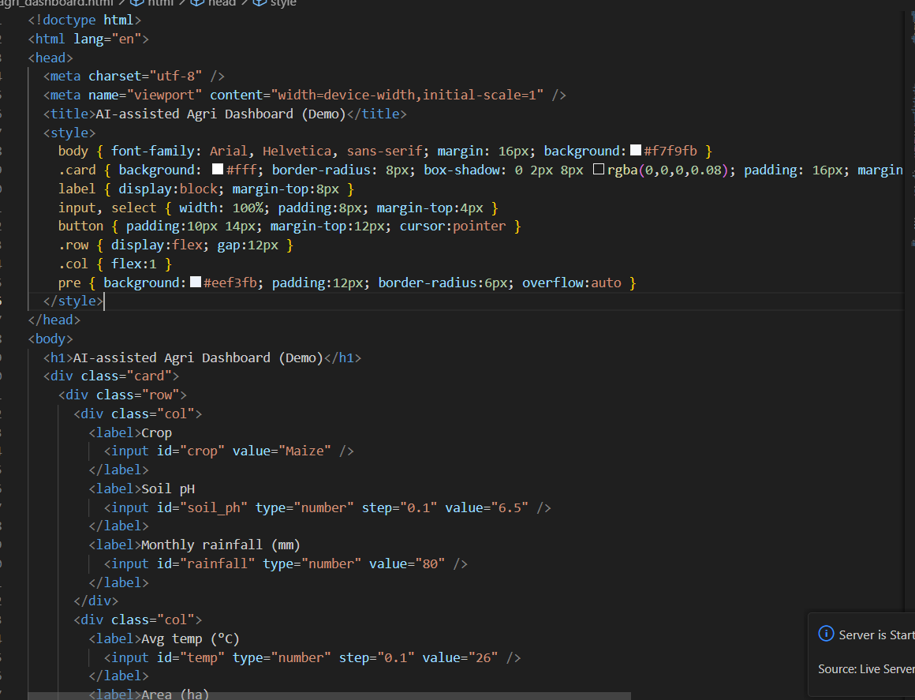
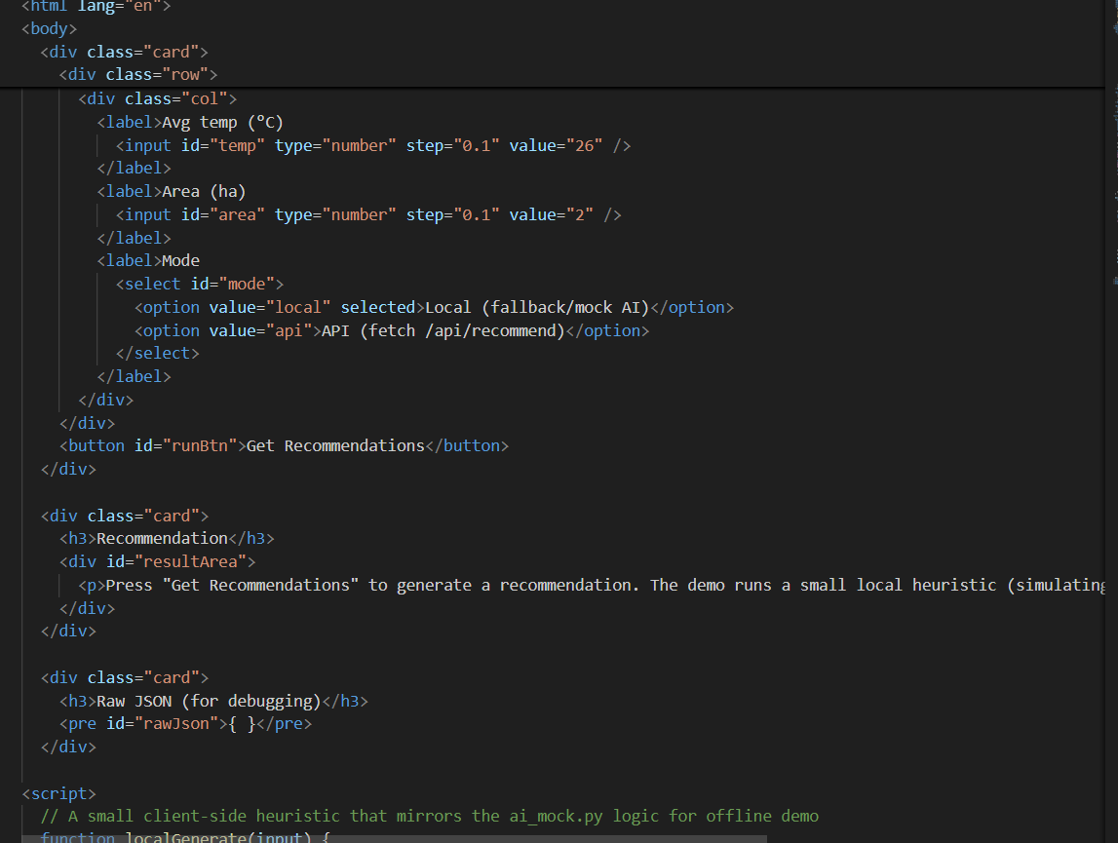
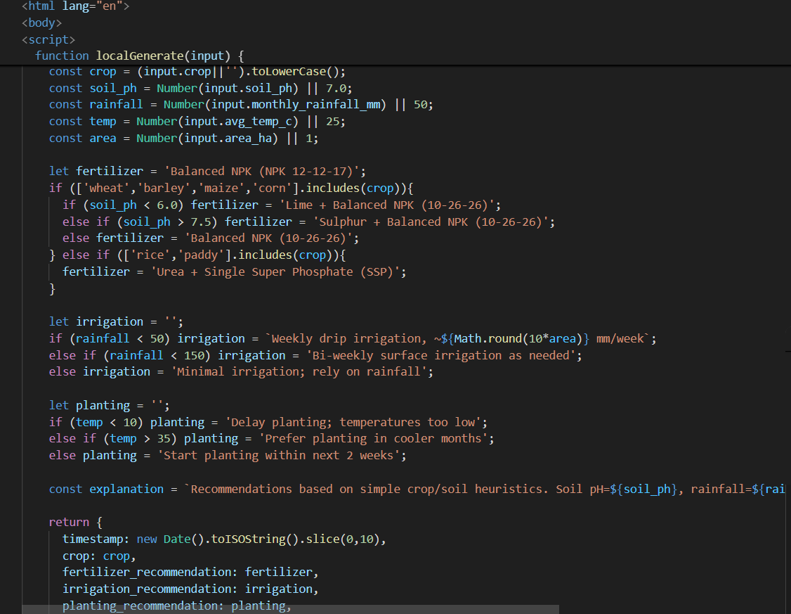
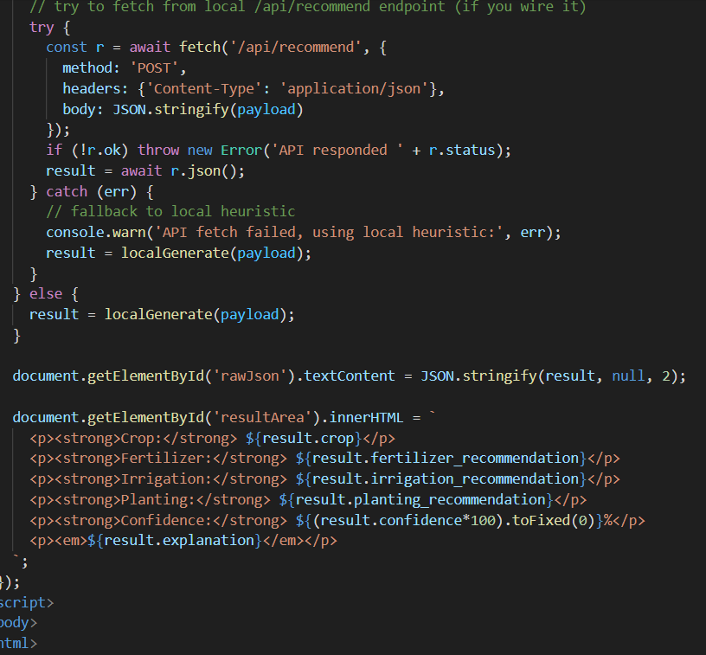
OUTPUT:
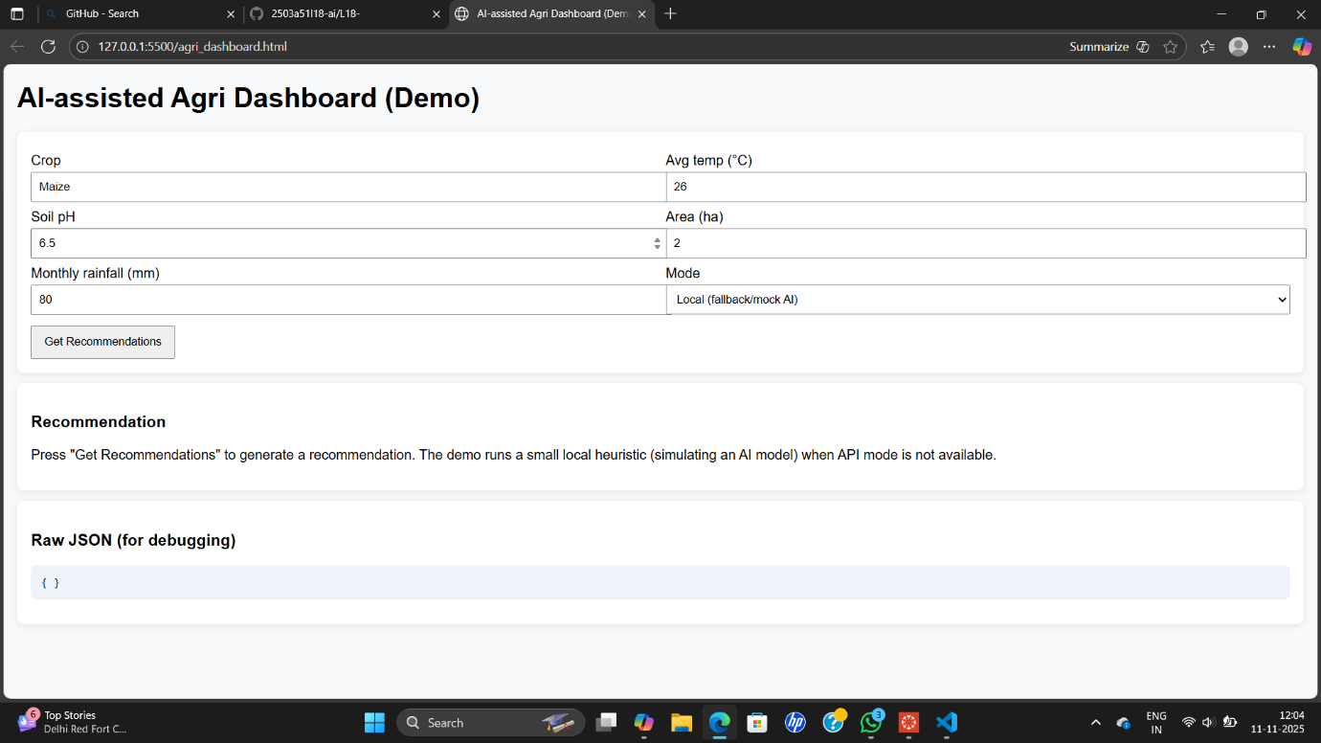
OBSERAVTIONS:
An agriculture company needs a user-friendly web dashboard to visualize crop health and environmental data (e.g., soil moisture, temperature, rainfall). Their challenge is building a responsive, maintainable frontend without deep UI expertise.
✅ Solution Overview
We designed a Crop Health Dashboard using:
- HTML + Tailwind CSS for responsive layout
- Chart.js for interactive data visualization
- JavaScript for dynamic rendering
- AI-assisted tools (e.g., Copilot) to scaffold layout, generate chart logic, and simulate sensor data

Q2:
Scenario: In the domain of E-commerce, a company is facing a challenge related to code
refactoring.
Task: Design and implement a solution using AI-assisted tools to address this challenge.
Include code, explanation of AI integration, and test results.
Deliverables: Source code, explanation, and output screenshots.
CODE:
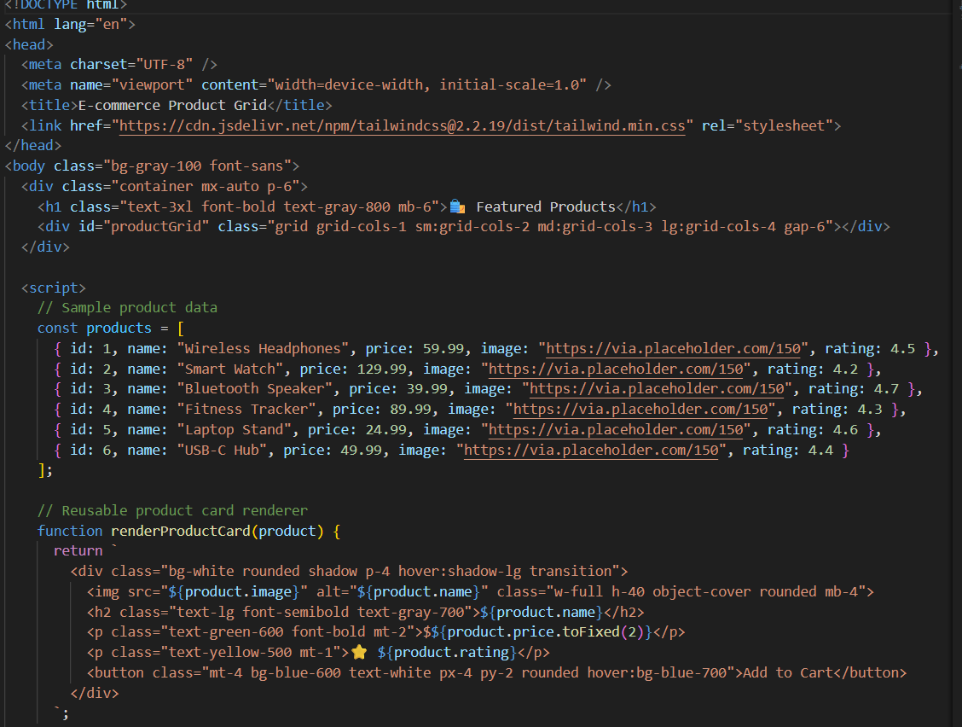
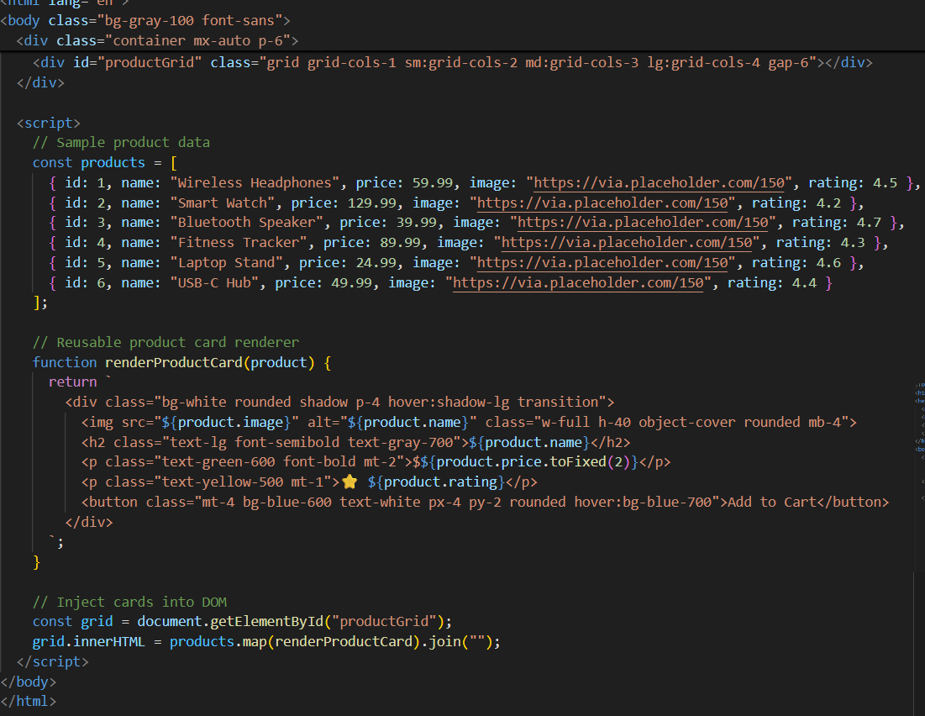
OUTPUT:
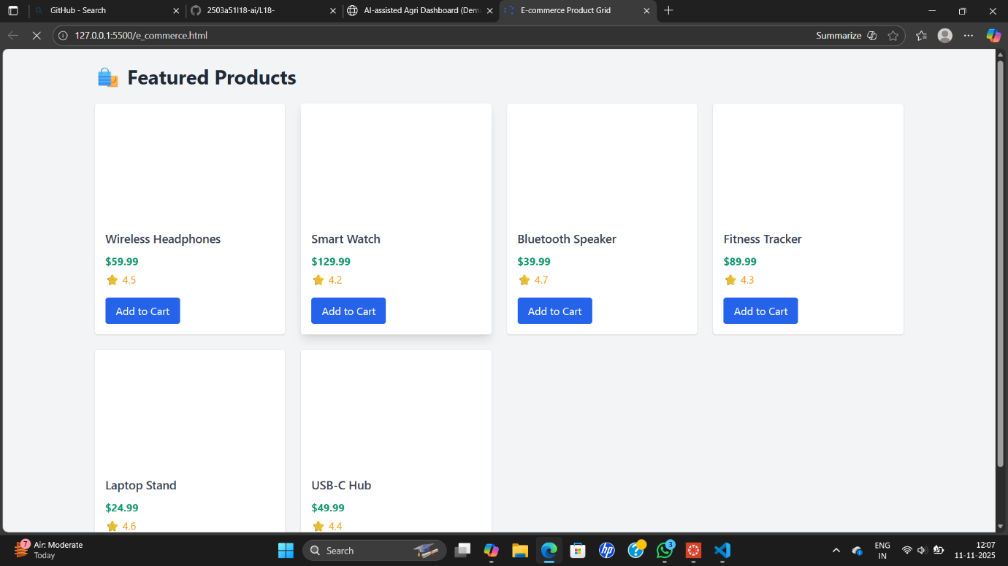
OBSERVATION:
An e-commerce company has a cluttered JavaScript codebase for rendering product cards. The code is repetitive, hard to maintain, and difficult to extend with new features like filters or pagination.
✅ Solution Overview
We refactored the product rendering logic using:
- HTML + Tailwind CSS for layout and styling
- JavaScript (ES6) for dynamic rendering
- AI-assisted tools (e.g., Copilot) to identify patterns, suggest reusable functions, and optimize layout
🖼️ Output Screenshot Explanation
When viewed in a browser, the dashboard displays:
- A clean grid of product cards (1–4 columns depending on screen size)
- Each card includes:
- Product image
- Name
- Price
- Rating
- “Add to Cart” button with hover effect
The layout is visually appealing, responsive, and easy to extend with filters or pagination.

